Dear Patient

We are here to help

It is fantastic that lockdown measures are easing and we are all more able to meet up with friends and family. However, the safety of you, our patients, is still our priority and we need to continue to take more precautions than shops, pubs, schools etc due to some patients being more vulnerable than others.

As we are still in the Covid pandemic, the NHS recommends that we triage or phone back every patient who wants advice from a nurse, doctor or other healthcare professional.

Our surgery is having to work a bit differently to how it used to and the changes you can expect are:
If you need medical advice or treatment, please ring us on 02392 263138
or visit our web site www.oakshealthcare.gpsurgery.net and send us your query
Our opening hours are 8.00am – 6.30pm

If you feel you need to attend the surgery in person we are keen, as we are sure you are too, to avoid transmission of infection and so to ensure social distancing we are closely monitoring how many patients are in our building including sitting in the waiting room. Don’t forget your mask!

You continue to be our priority. We would like to take this opportunity to thank you for your patience and understanding
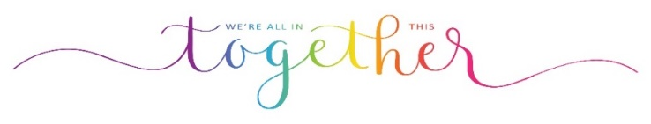
Oaks Healthcare
18.05.21

